**HoldTest  
03/11/2020 15:32:41**  
User Is Navigated To Site : http://172.19.9.53/ICRARevamp/#/login  
  
*****HoldTest is Started *****  
Username is entered  
  
Password is entered  
  
Submit button is clicked  
Text of the element : Successfully logged in  
Successfully logged in  
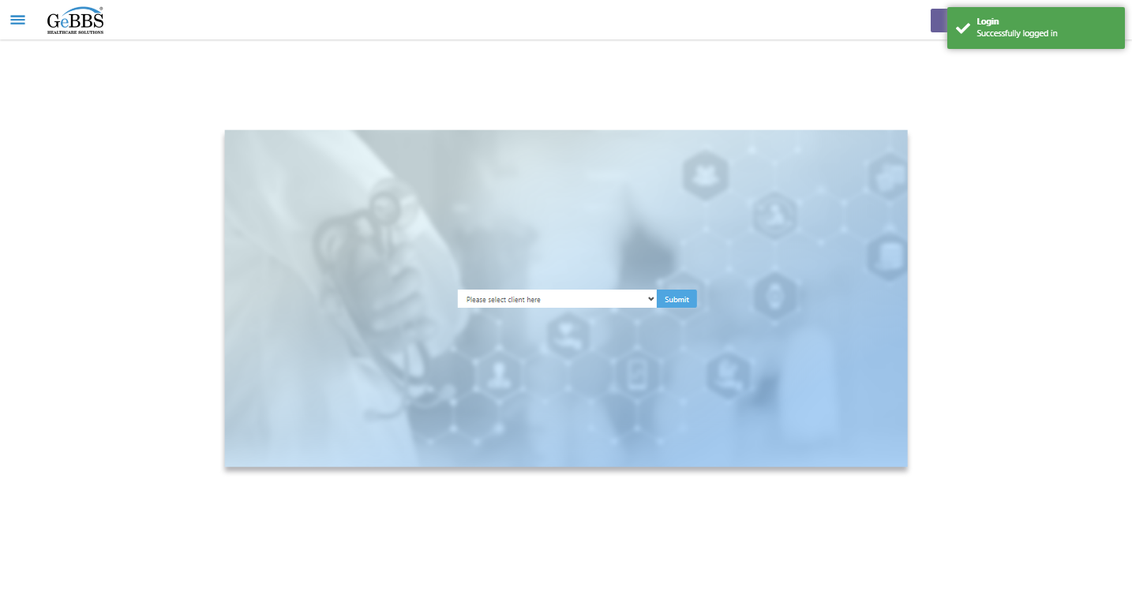  
Client dropdown button is clicked  
Client dropdown button is clicked  
Submit button is clicked  
Main Page loaded  
  
Scrolled successfully  
Chart Retrieval is clicked  
All submenus  
  
Submenu in 1 is :Field Tech  
Submenu in 2 is :FieldTech Area Assignment  
Submenu in 3 is :Intake  
Submenu in 4 is :RecordQA  
Submenu in 5 is :RecordQA Approval  
Scrolled successfully  
RecordQA is clicked  
RecordQA selected  
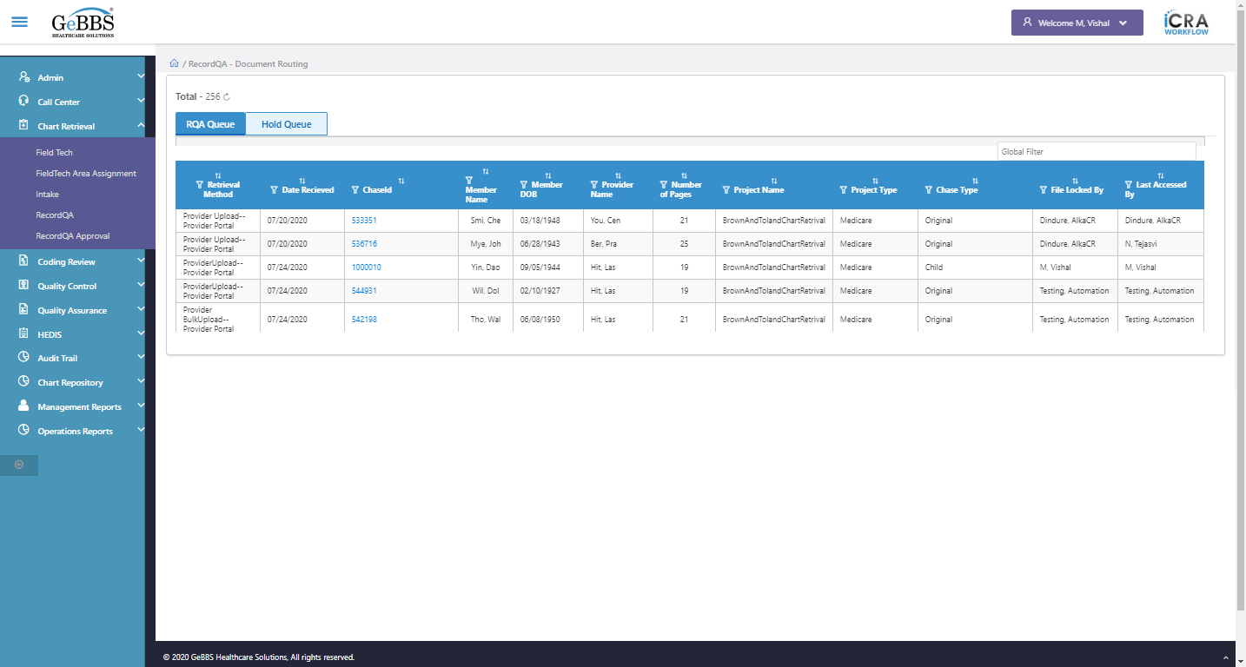  
Scrolled successfully  
Scrolled successfully  
Scrolled successfully  
Scrolled successfully  
Scrolled successfully  
Scrolled successfully  
Scrolled successfully  
Scrolled successfully  
Scrolled successfully  
Scrolled successfully  
Scrolled successfully  
Scrolled successfully  
Text of the element : 1000024  
GolbalFilter is entered  
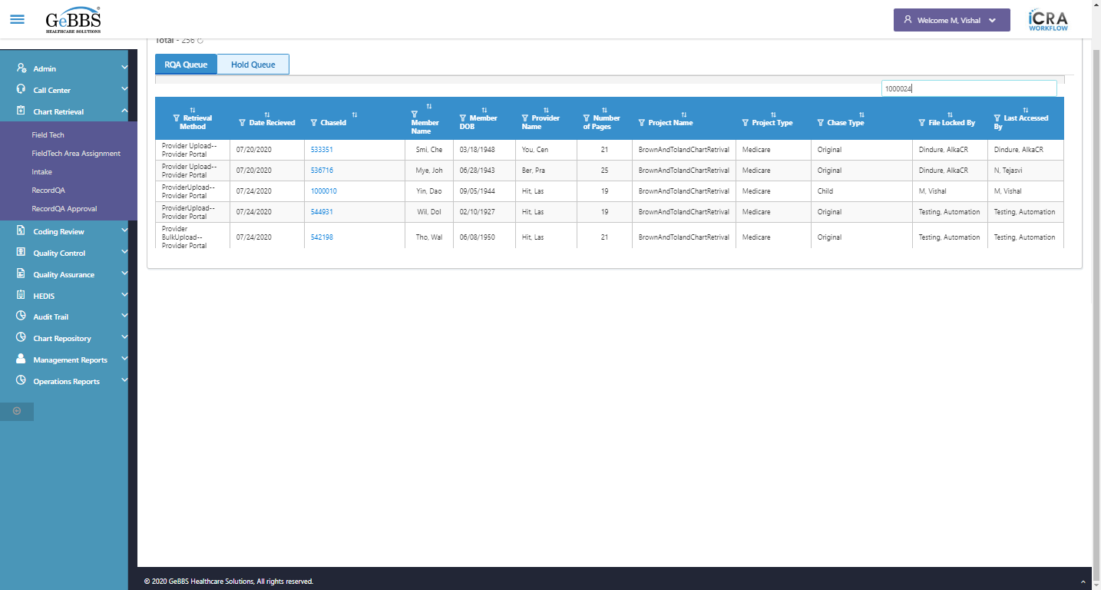  
Text of the element : 4  
chaseid is clicked  
Scrolled successfully  
Hold is clicked  
Scrolled successfully  
Close_HoldWin is clicked  
Close button oF hold window working  
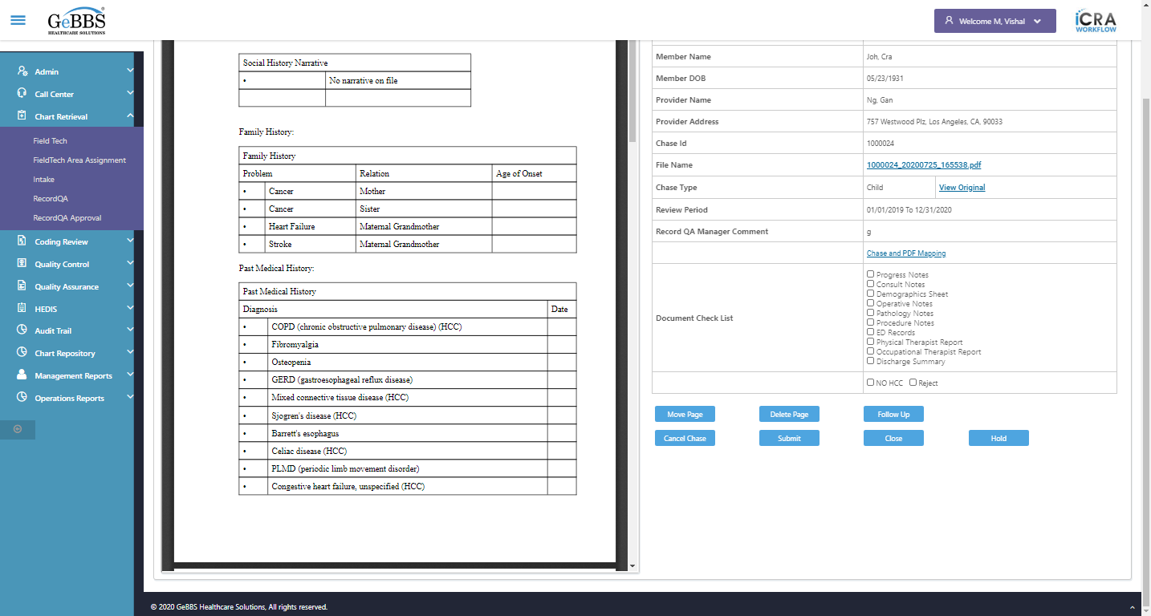  
Scrolled successfully  
Hold is clicked  
Reason_HoldWin is displayed  
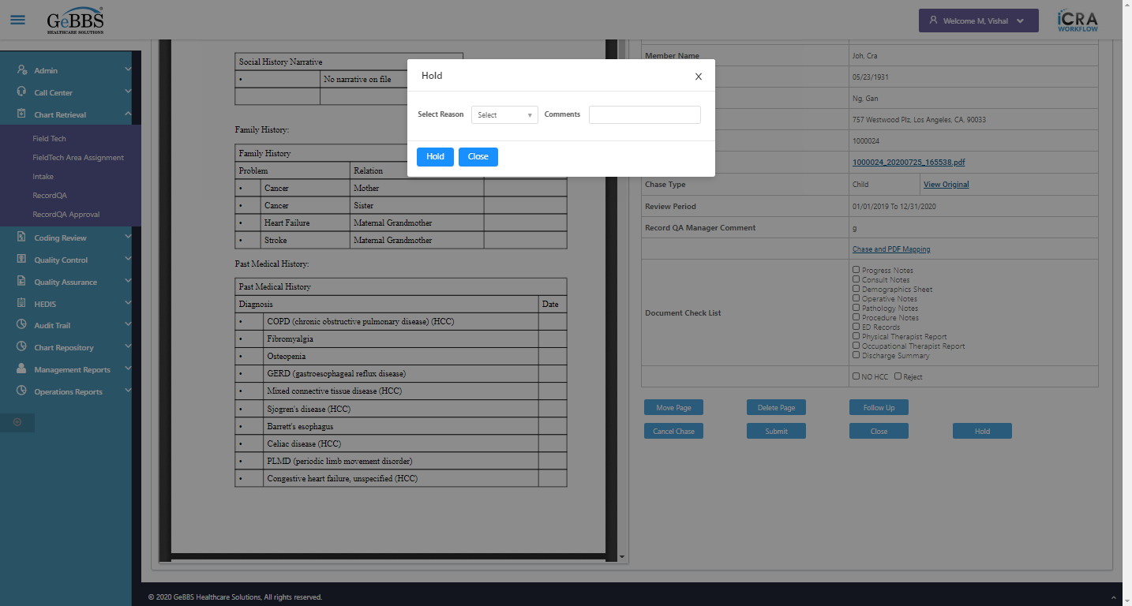  
Comm_HoldWin is displayed  
  
MovePage is displayed  
  
DeletePage is displayed  
  
Scrolled successfully  
Hold_HoldWin is clicked  
HoldReasonalert is correct  
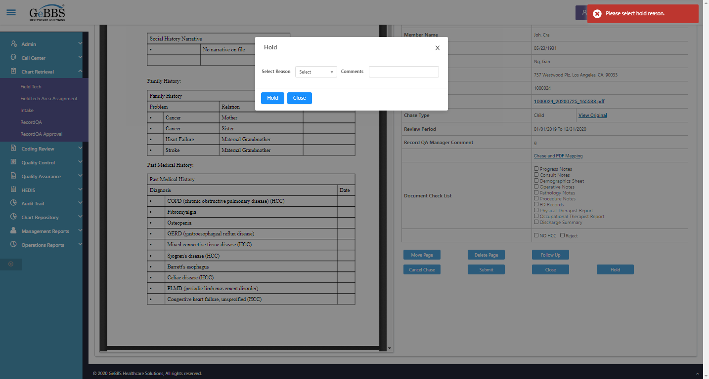  
Drop down option with visible text Hold Reason 2 is selected  
Comm_HoldWin is entered  
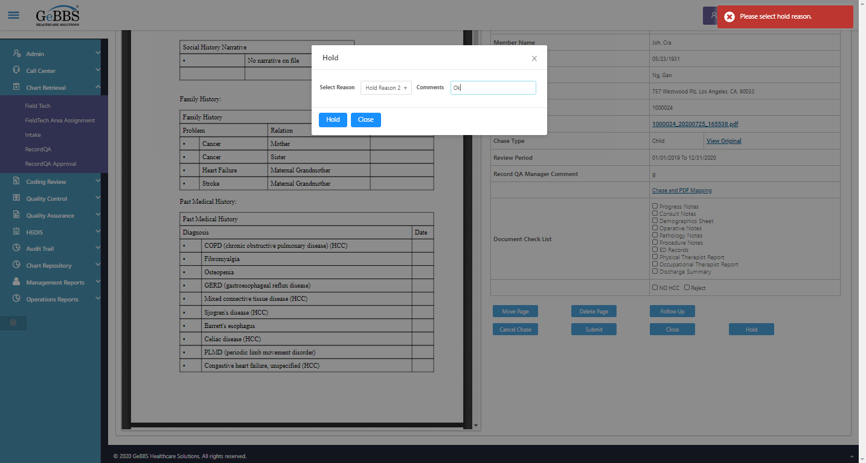  
Scrolled successfully  
Hold_HoldWin is clicked  
HoldChaseSuccess msg correct  
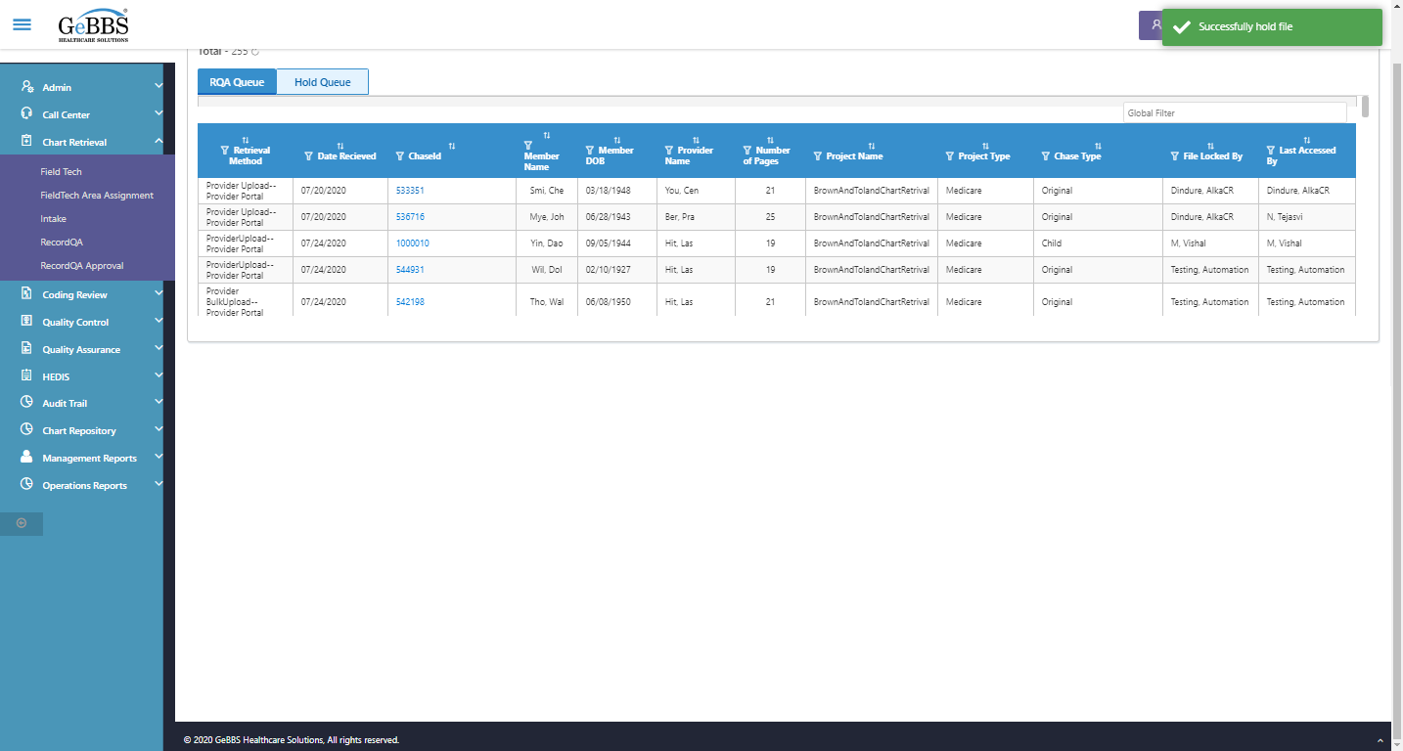  
Record count correct  
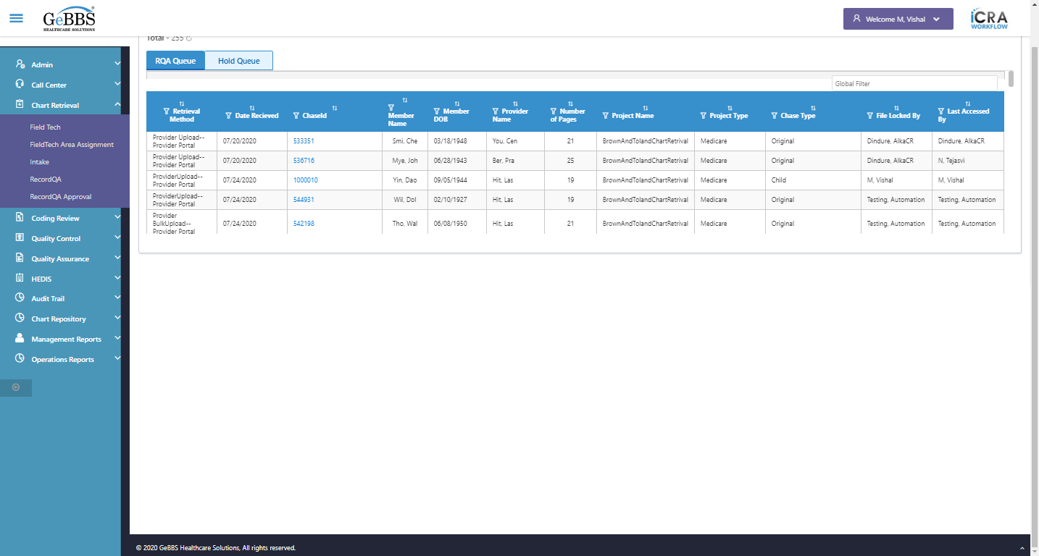  
RecordQA scrren is displayed  
  
HoldQueueBucket is clicked  
GolbalFilter is entered  
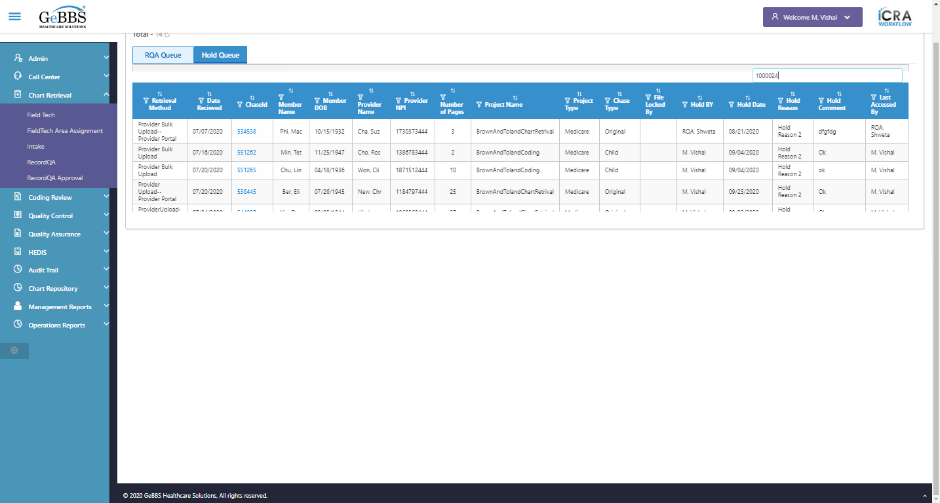  
 Retrieval Method is displayed  
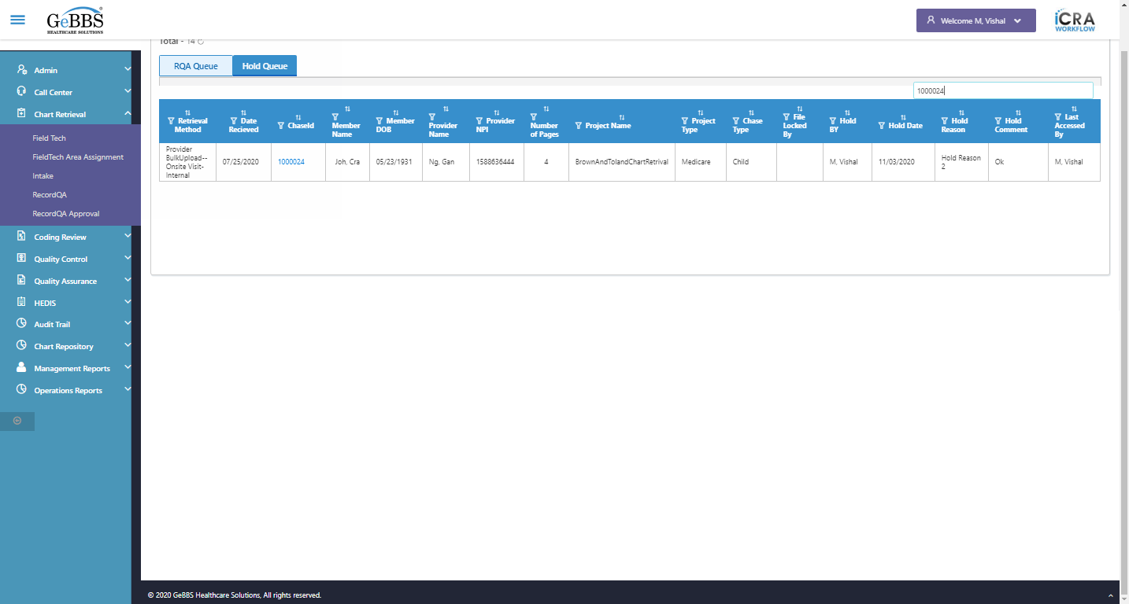  
text is correct  
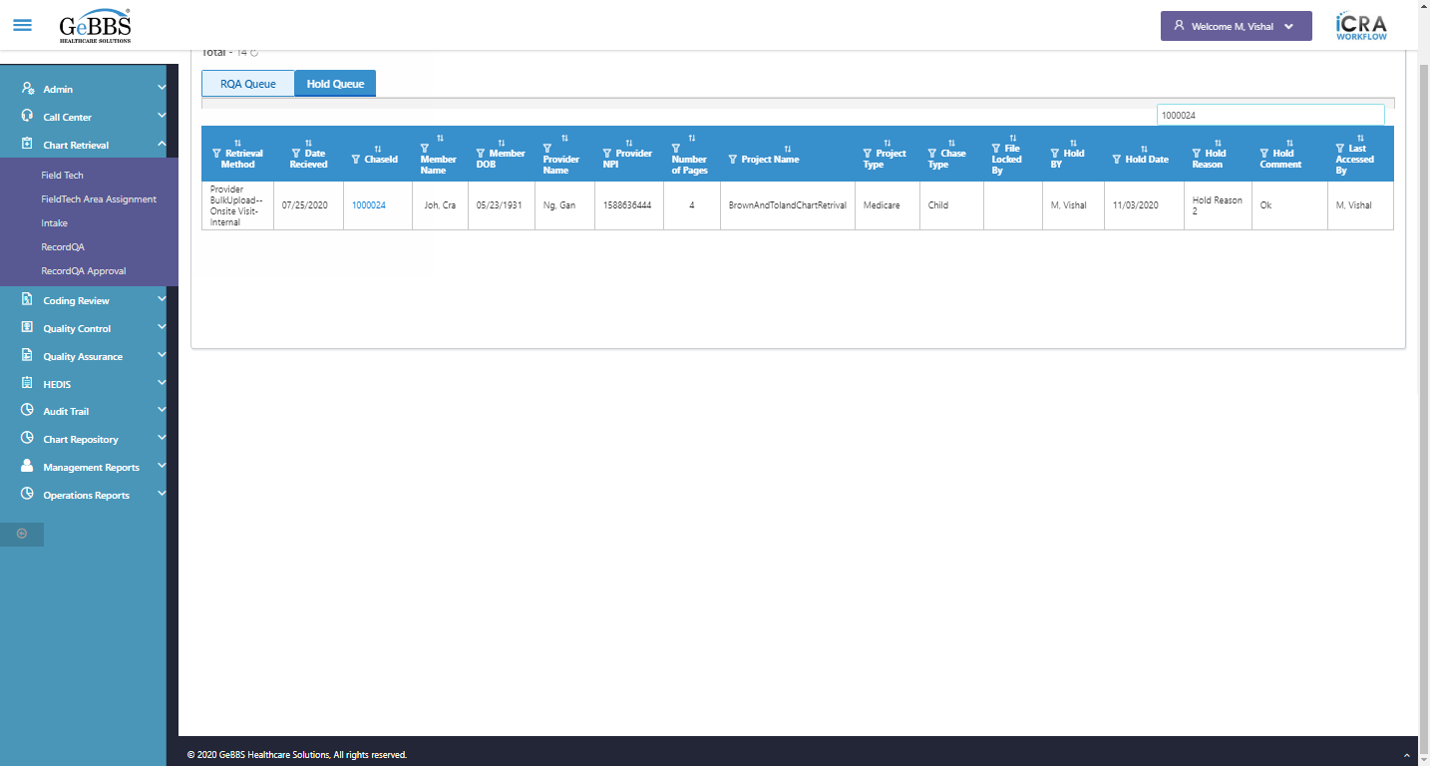  
1 th filter is displayed  
  
1 th sorting is displayed  
  
Sort is clicked  
1 th Asc-sorting is displayed  
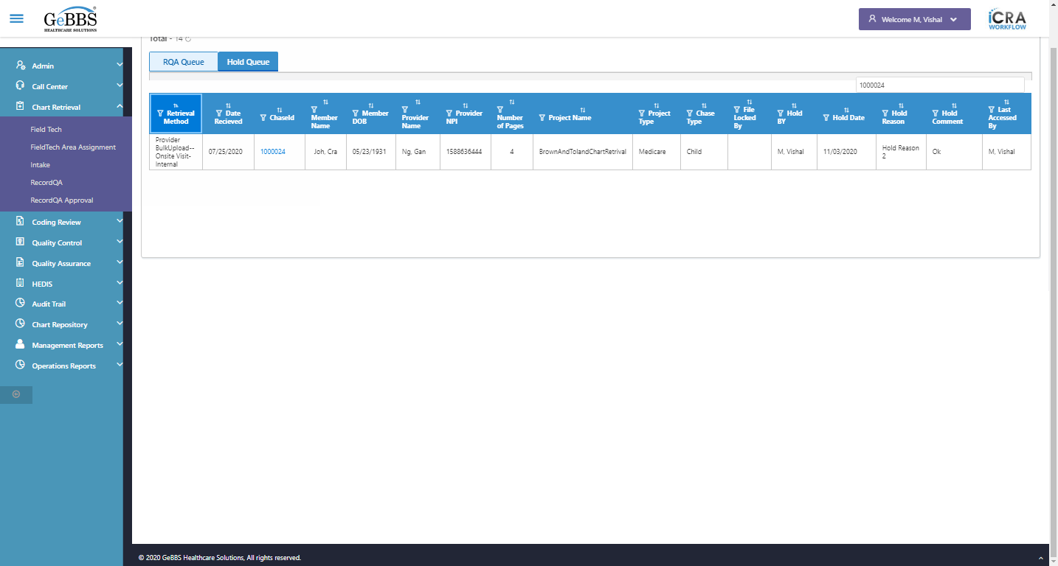  
Sort is clicked  
1 th dsc-sorting is displayed  
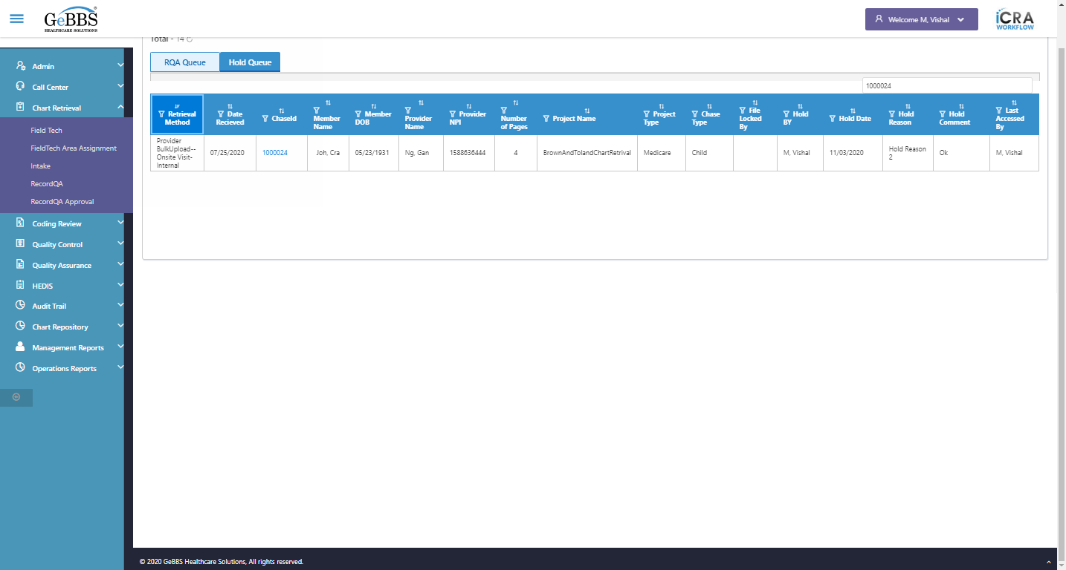  
 Date Recieved is displayed  
  
text is correct  
  
2 th filter is displayed  
  
2 th sorting is displayed  
  
Sort is clicked  
2 th Asc-sorting is displayed  
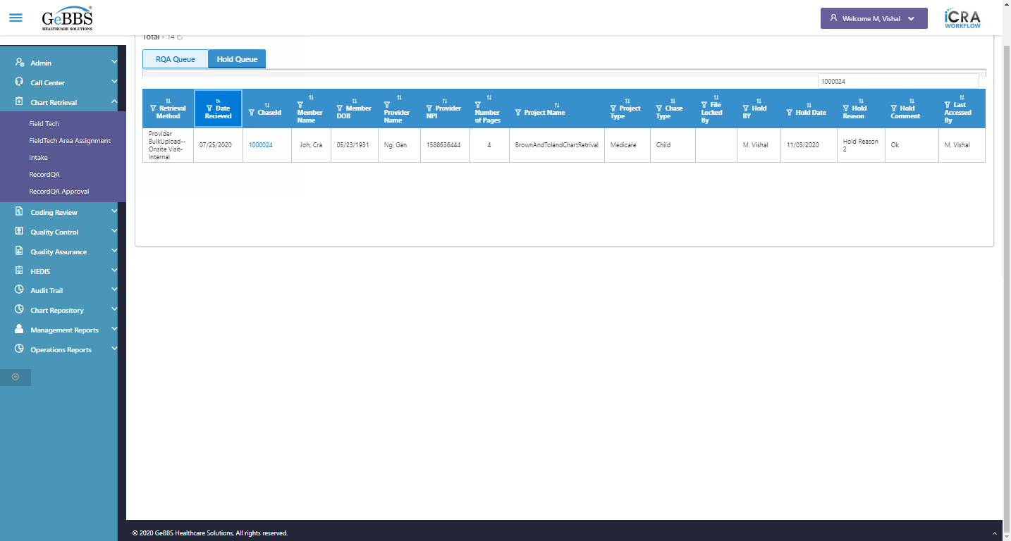  
Sort is clicked  
2 th dsc-sorting is displayed  
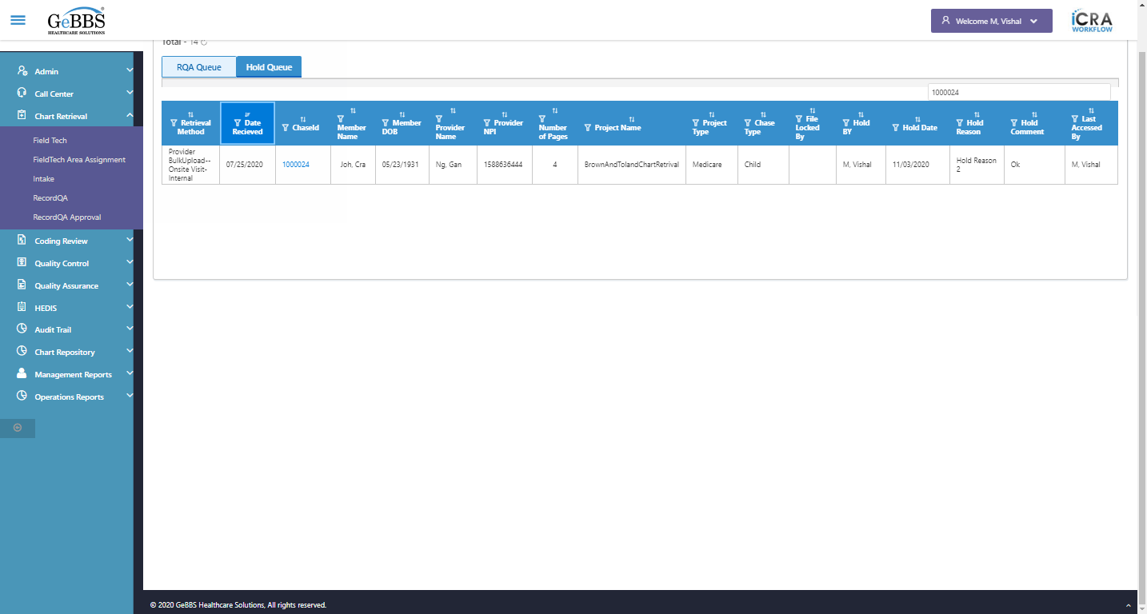  
 ChaseId is displayed  
  
text is correct  
  
3 th filter is displayed  
  
3 th sorting is displayed  
  
Sort is clicked  
3 th Asc-sorting is displayed  
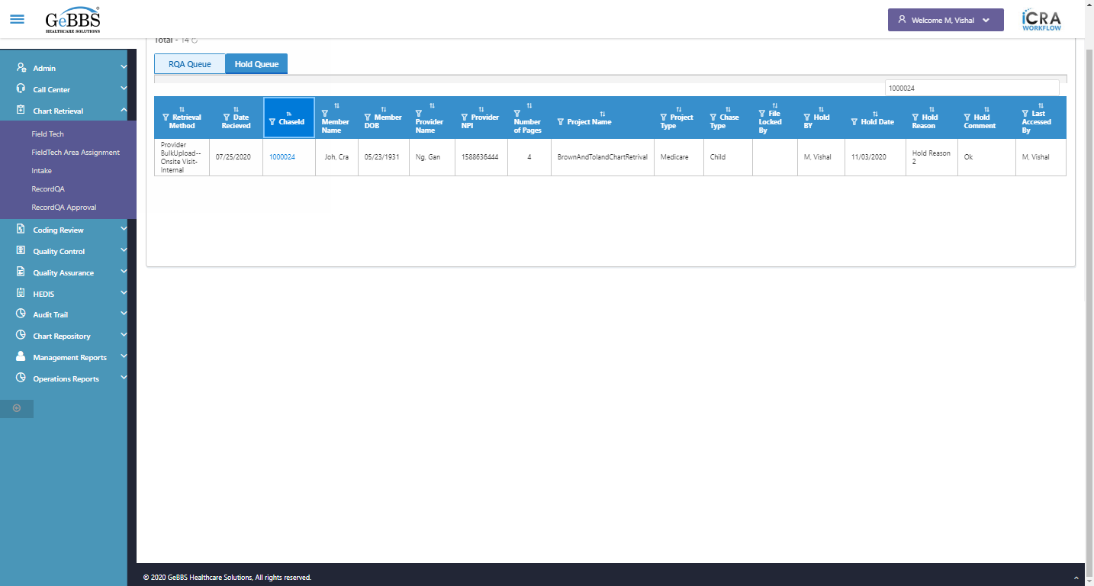  
Sort is clicked  
3 th dsc-sorting is displayed  
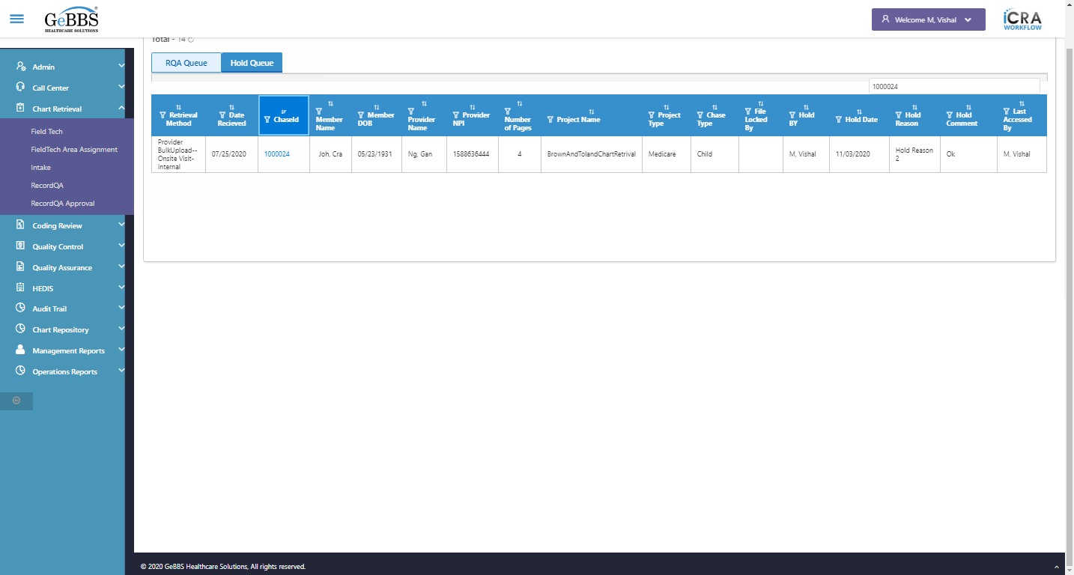  
 Member Name is displayed  
  
text is correct  
  
4 th filter is displayed  
  
4 th sorting is displayed  
  
Sort is clicked  
4 th Asc-sorting is displayed  
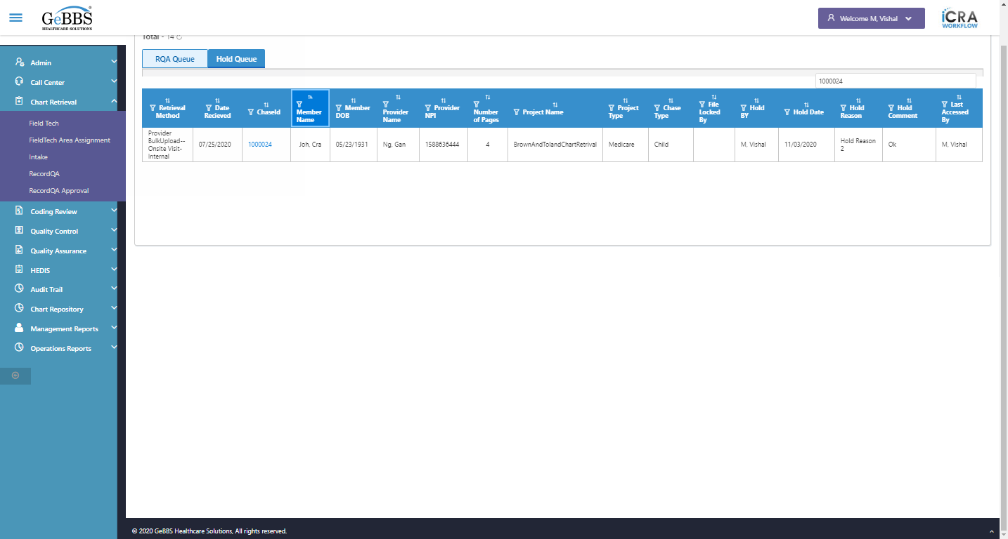  
Sort is clicked  
4 th dsc-sorting is displayed  
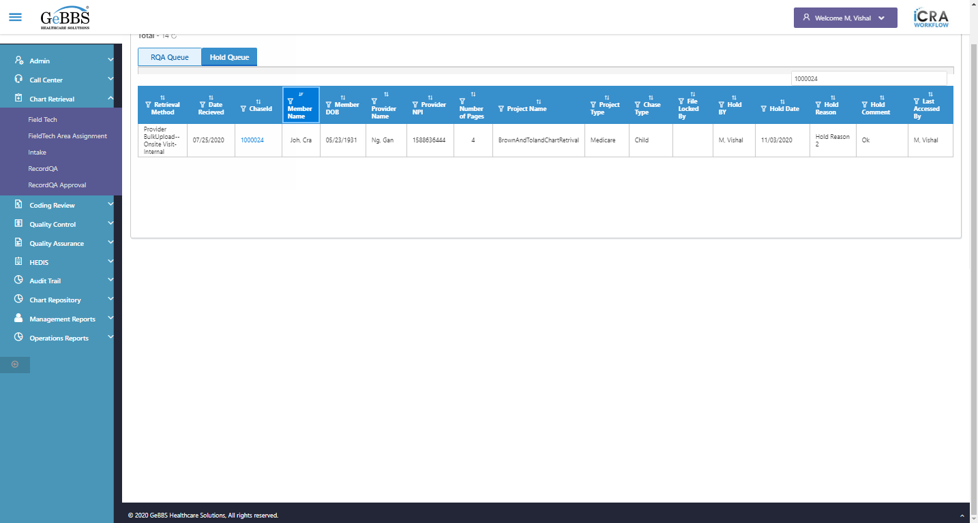  
 Member DOB is displayed  
  
text is correct  
  
5 th filter is displayed  
  
5 th sorting is displayed  
  
Sort is clicked  
5 th Asc-sorting is displayed  
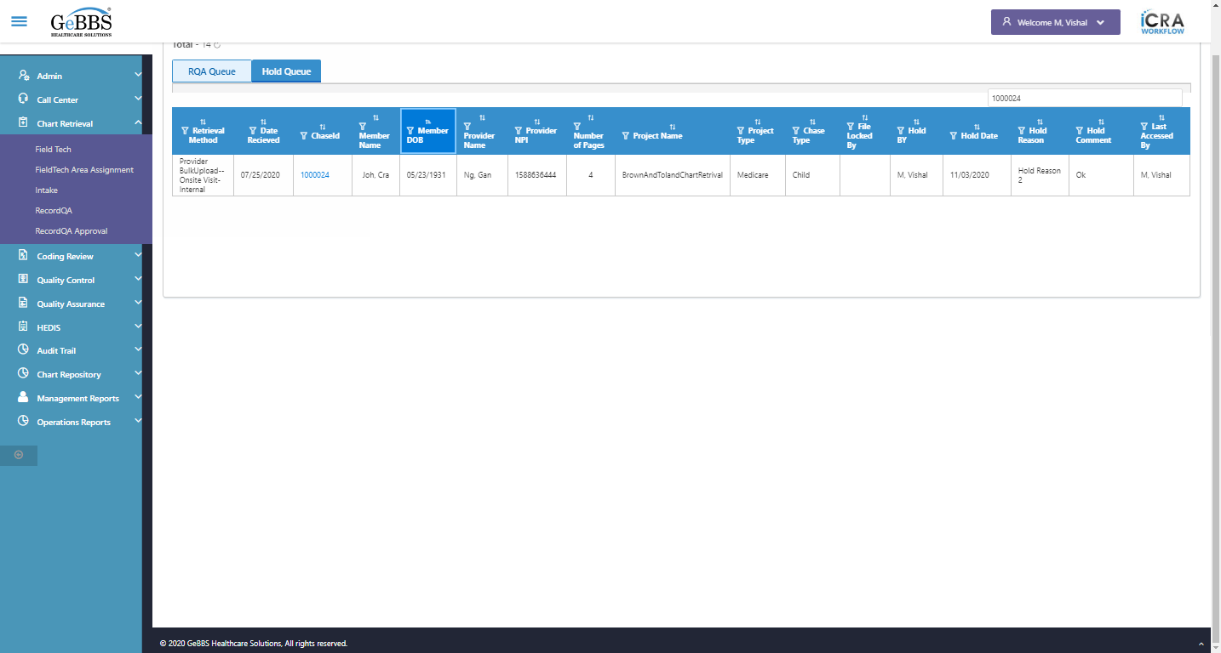  
Sort is clicked  
5 th dsc-sorting is displayed  
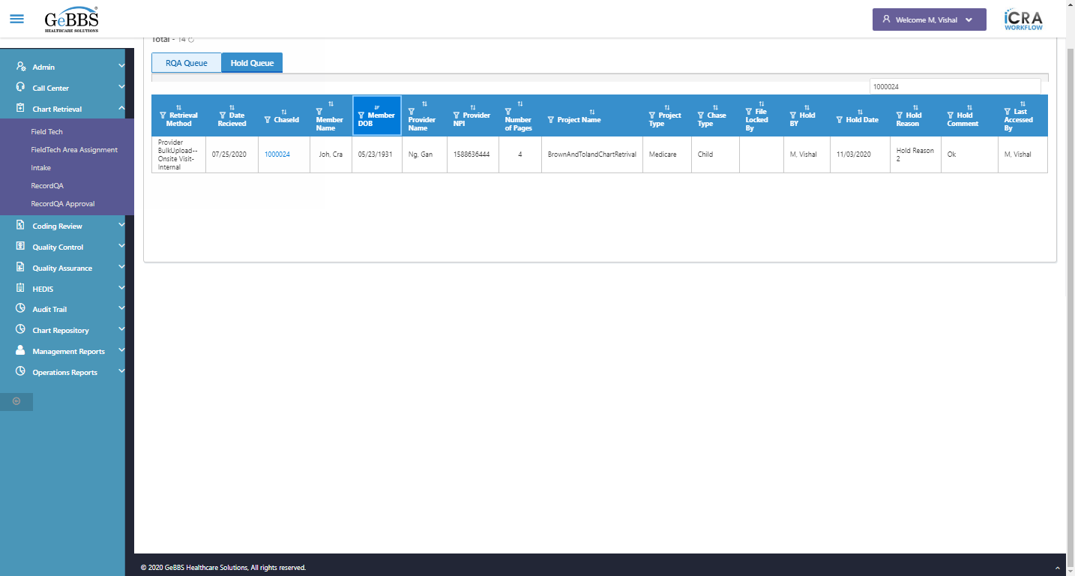  
 Provider Name is displayed  
  
text is correct  
  
6 th filter is displayed  
  
6 th sorting is displayed  
  
Sort is clicked  
6 th Asc-sorting is displayed  
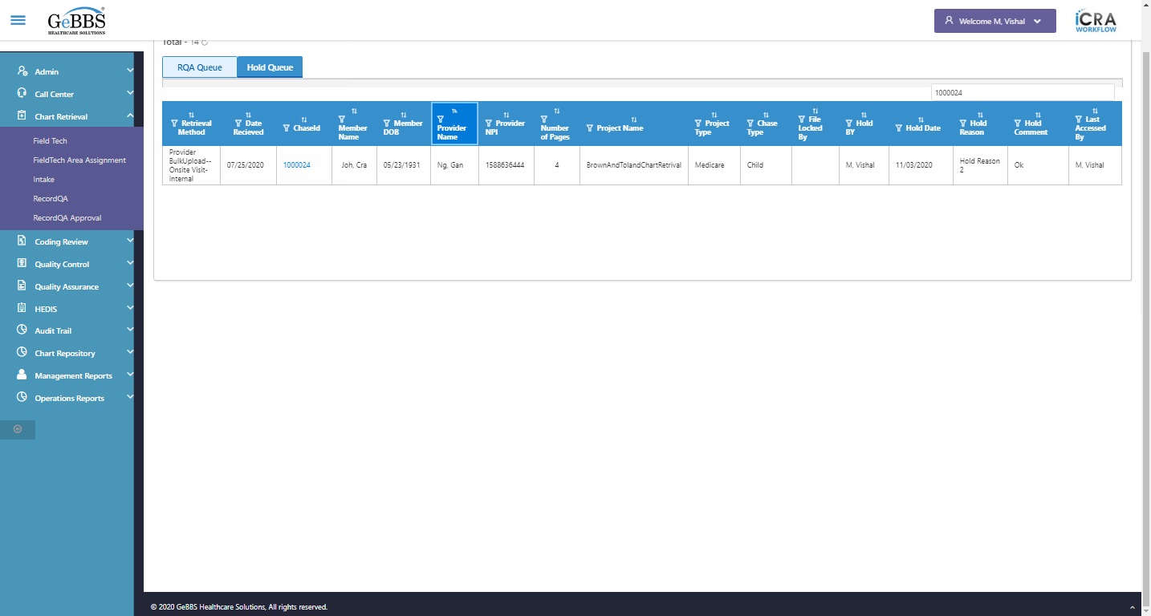  
Sort is clicked  
6 th dsc-sorting is displayed  
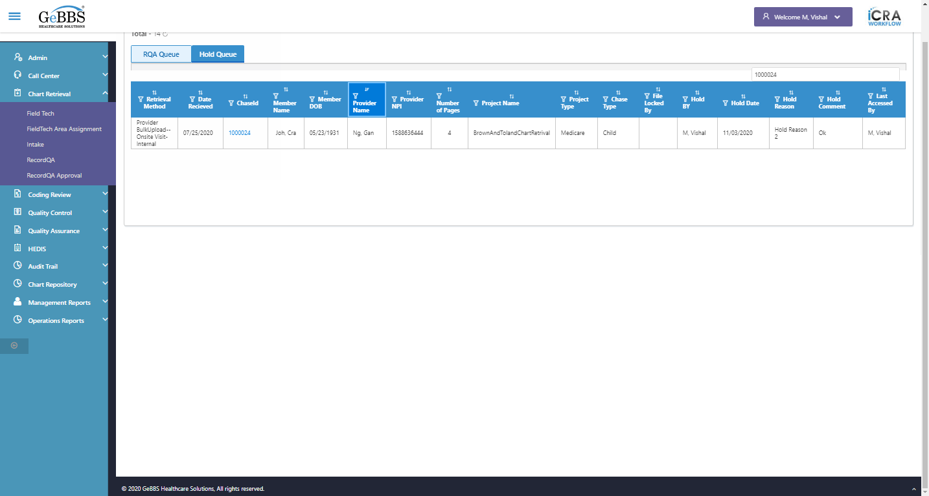  
 Provider NPI is displayed  
  
text is correct  
  
7 th filter is displayed  
  
7 th sorting is displayed  
  
Sort is clicked  
7 th Asc-sorting is displayed  
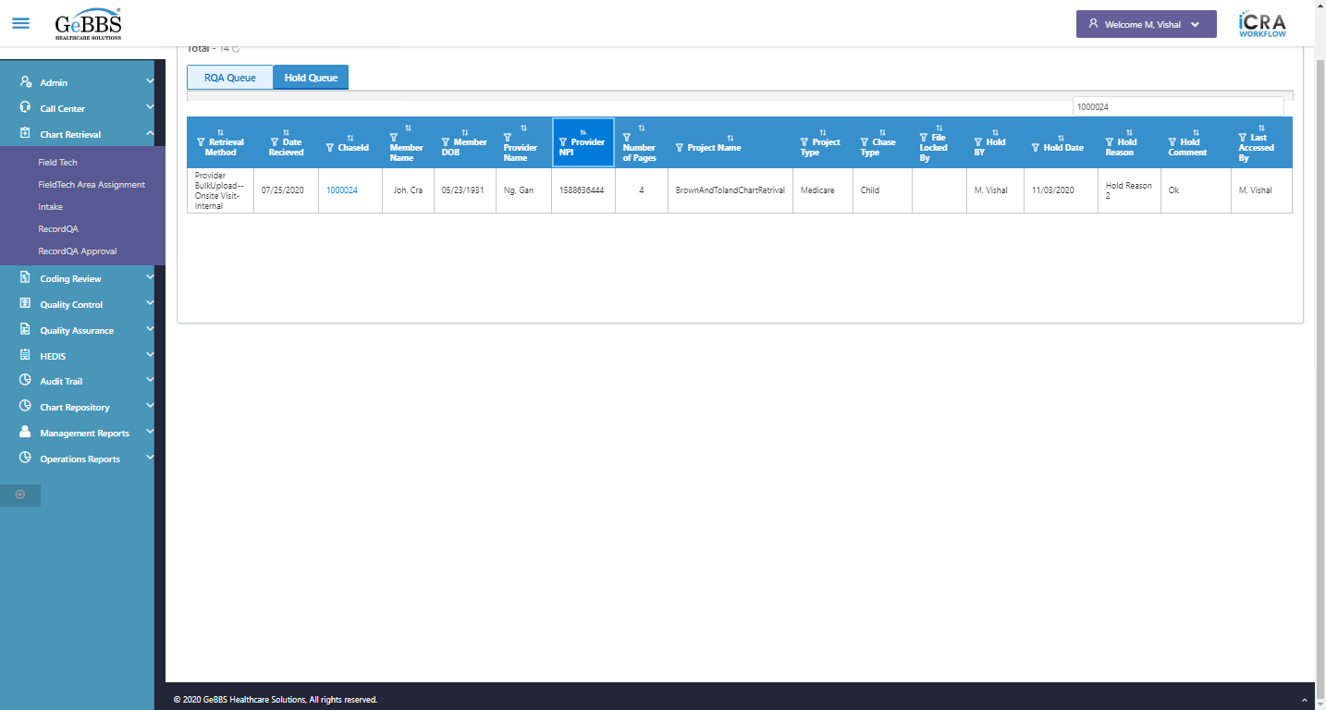  
Sort is clicked  
7 th dsc-sorting is displayed  
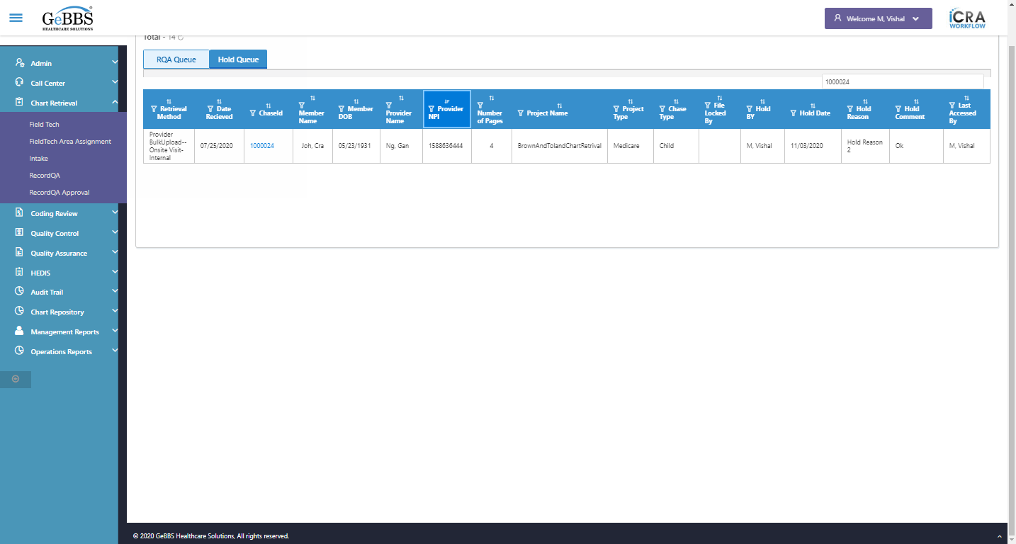  
 Number of Pages is displayed  
  
text is correct  
  
8 th filter is displayed  
  
8 th sorting is displayed  
  
Sort is clicked  
8 th Asc-sorting is displayed  
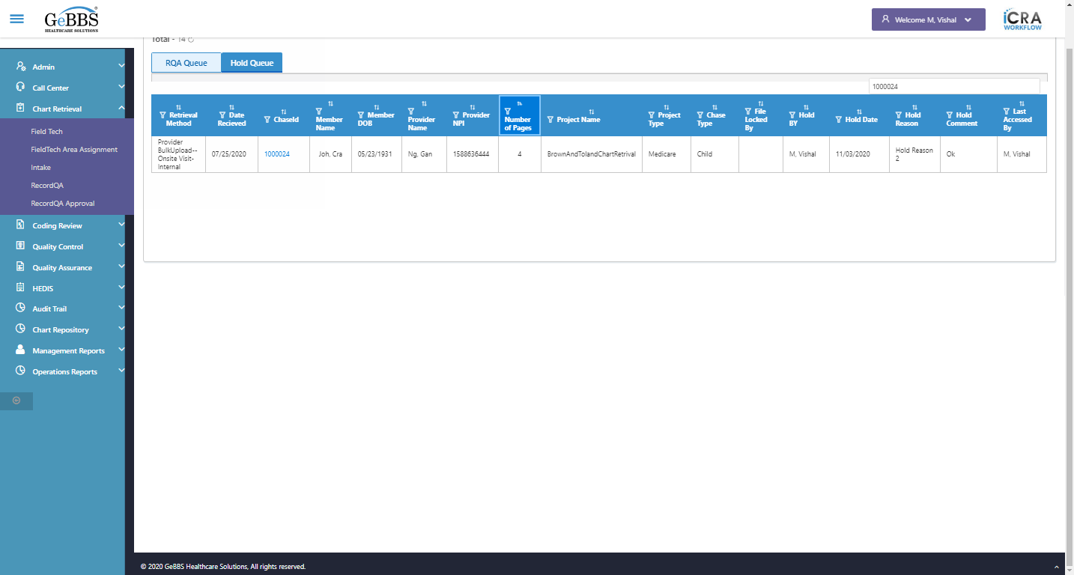  
Sort is clicked  
8 th dsc-sorting is displayed  
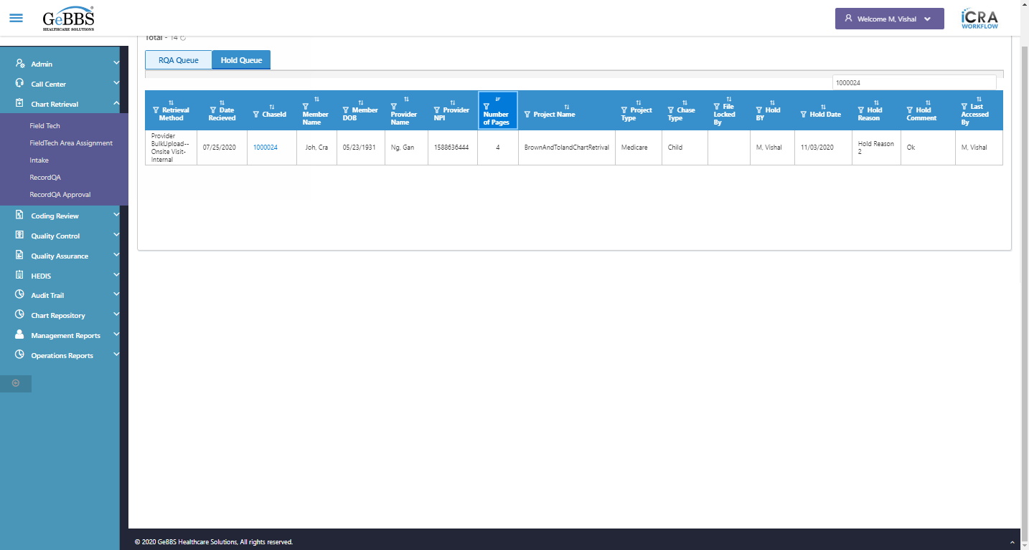  
 Project Name is displayed  
  
text is correct  
  
9 th filter is displayed  
  
9 th sorting is displayed  
  
Sort is clicked  
9 th Asc-sorting is displayed  
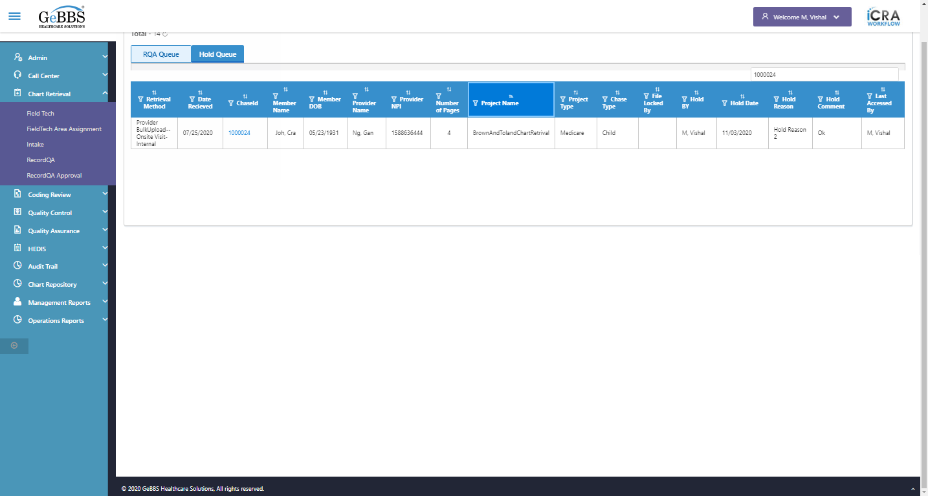  
Sort is clicked  
9 th dsc-sorting is displayed  
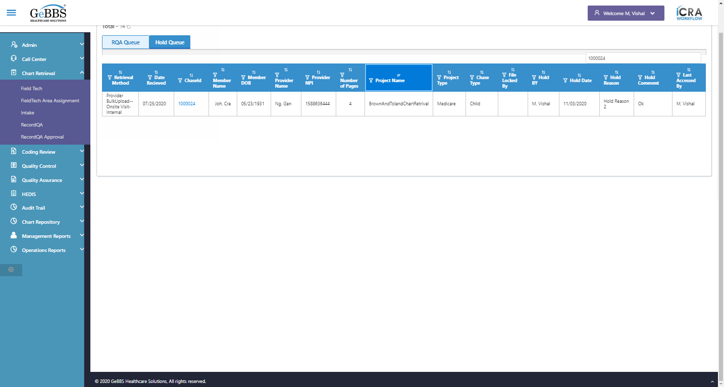  
 Project Type is displayed  
  
text is correct  
  
10 th filter is displayed  
  
10 th sorting is displayed  
  
Sort is clicked  
10 th Asc-sorting is displayed  
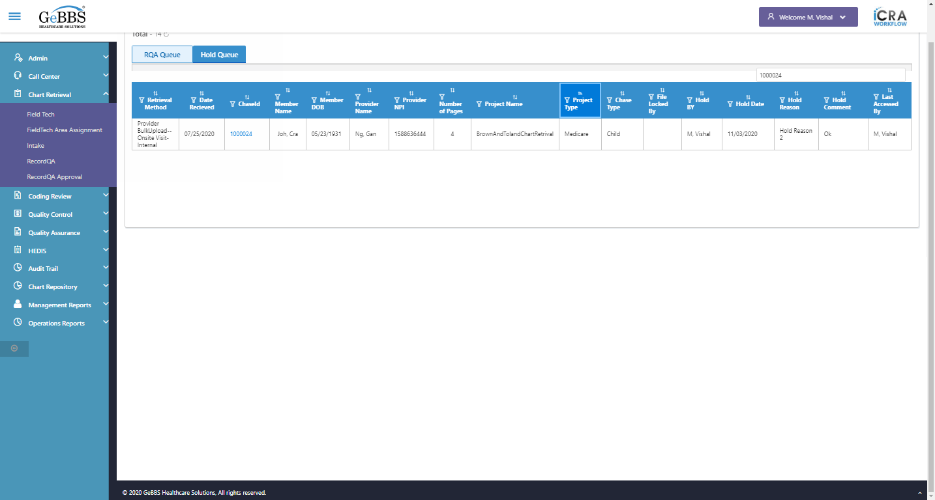  
Sort is clicked  
10 th dsc-sorting is displayed  
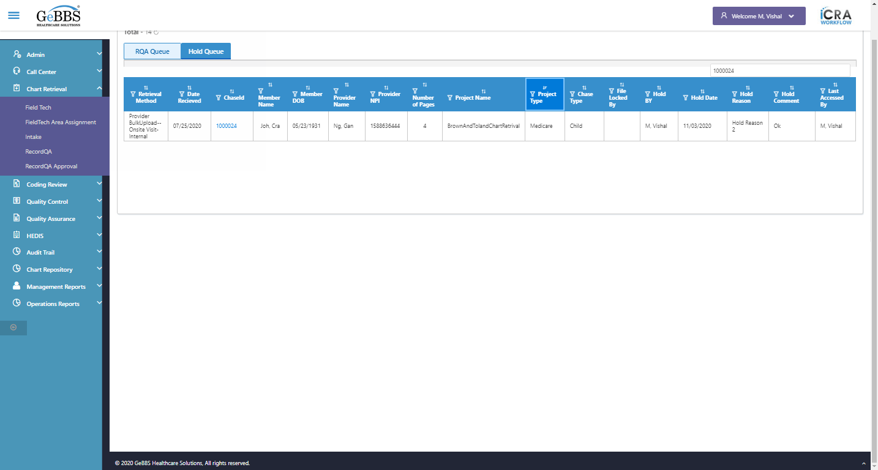  
 Chase Type is displayed  
  
text is correct  
  
11 th filter is displayed  
  
11 th sorting is displayed  
  
Sort is clicked  
11 th Asc-sorting is displayed  
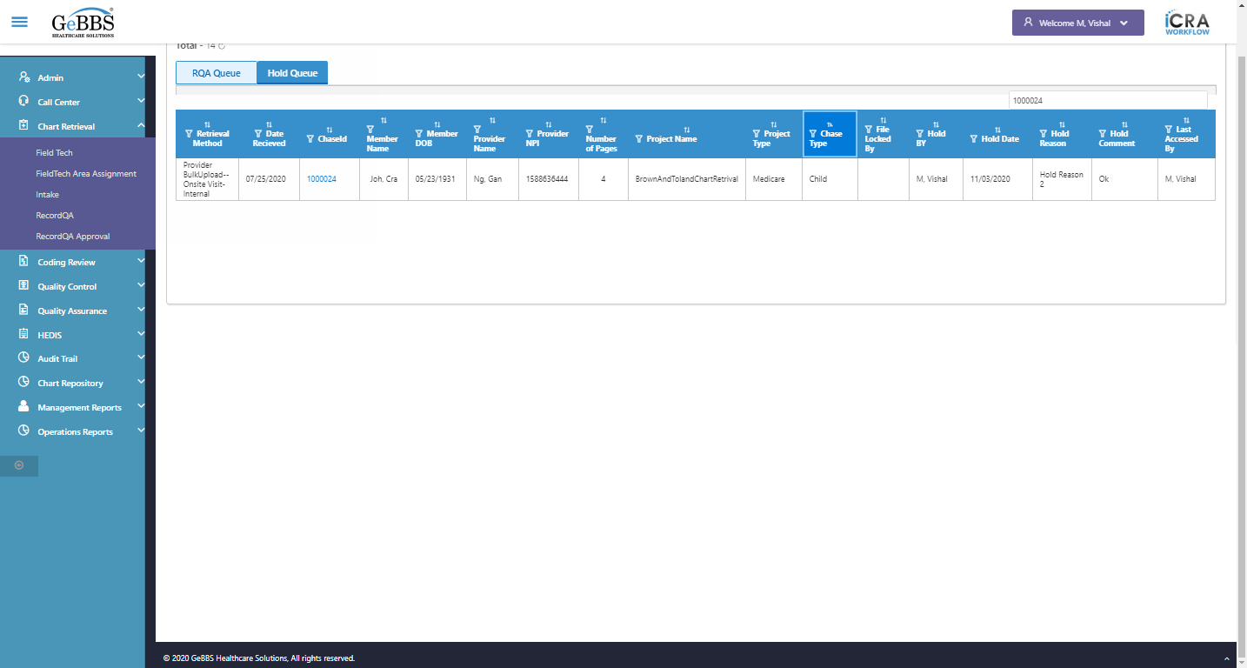  
Sort is clicked  
11 th dsc-sorting is displayed  
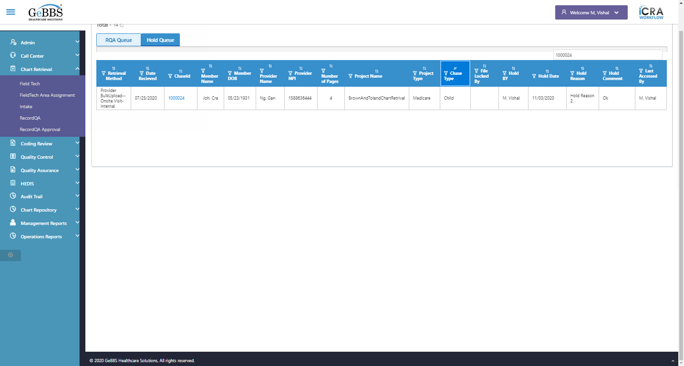  
 File Locked By is displayed  
  
text is correct  
  
12 th filter is displayed  
  
12 th sorting is displayed  
  
Sort is clicked  
12 th Asc-sorting is displayed  
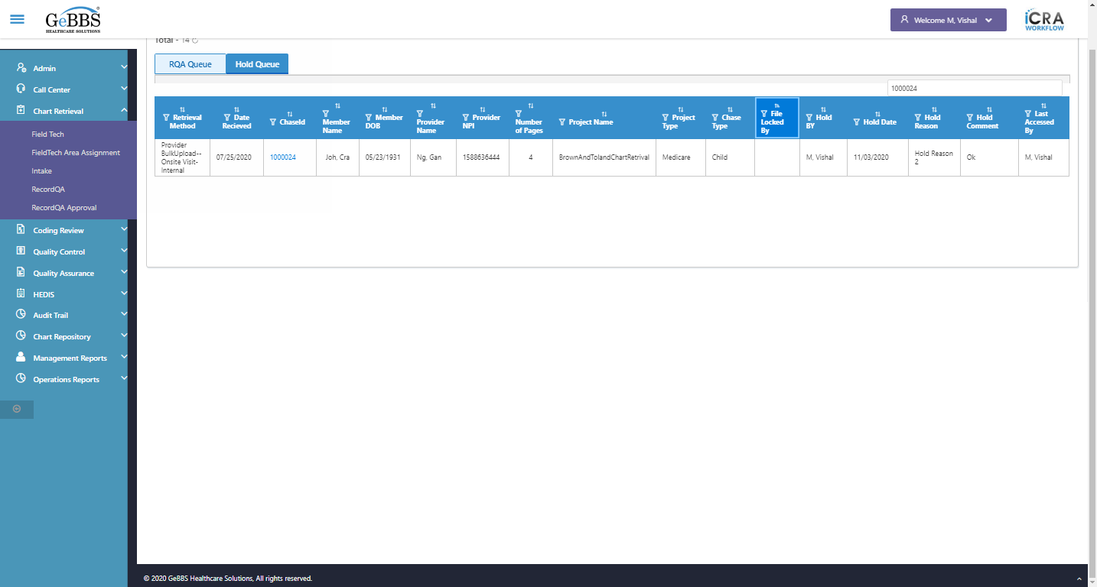  
Sort is clicked  
12 th dsc-sorting is displayed  
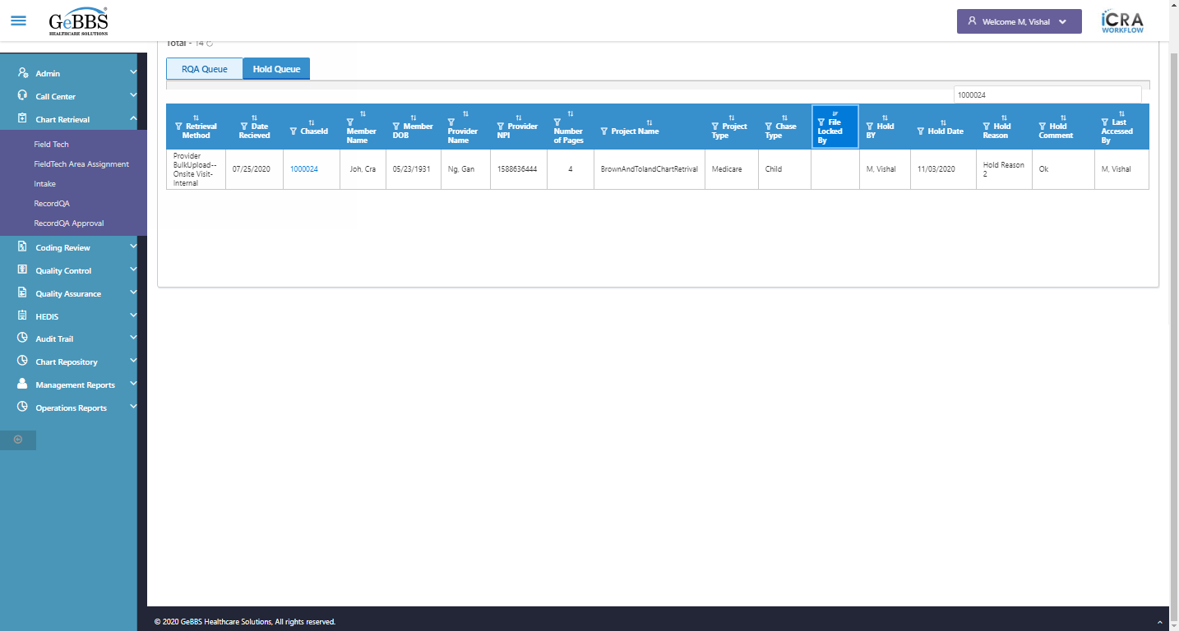  
 Hold BY is displayed  
  
text is correct  
  
13 th filter is displayed  
  
13 th sorting is displayed  
  
Sort is clicked  
13 th Asc-sorting is displayed  
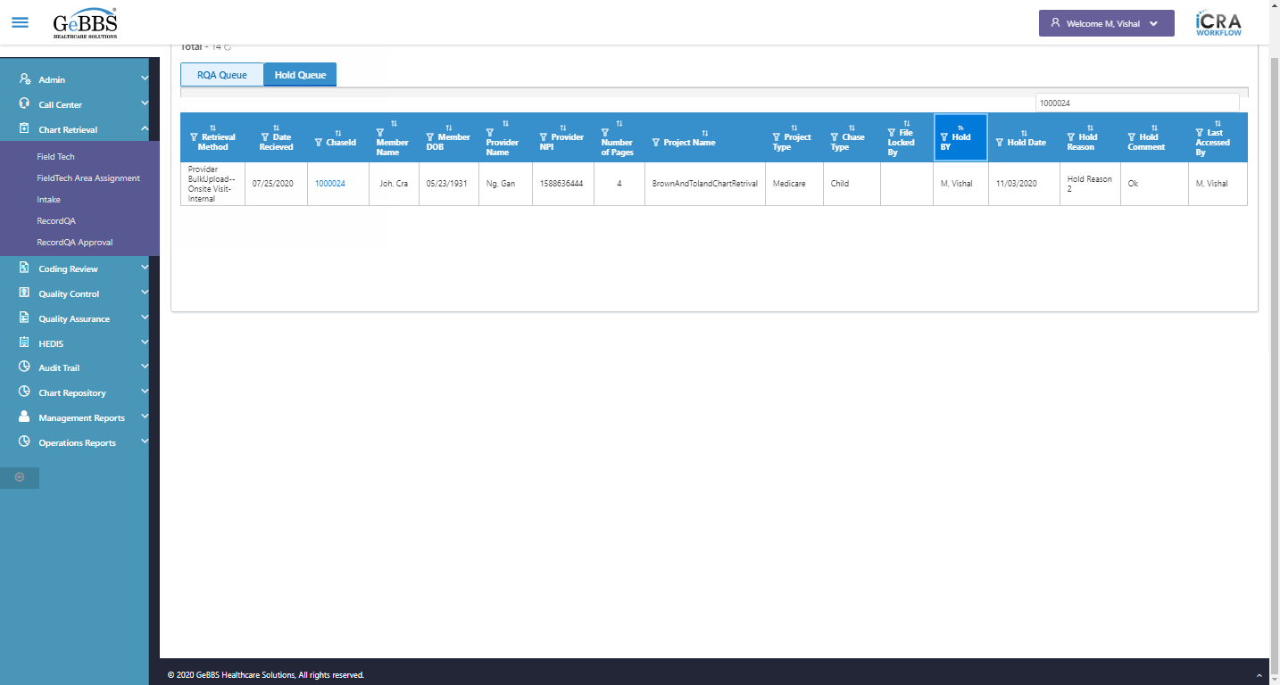  
Sort is clicked  
13 th dsc-sorting is displayed  
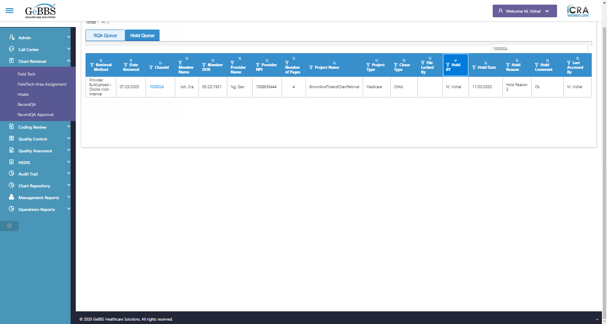  
 Hold Date is displayed  
  
text is correct  
  
14 th filter is displayed  
  
14 th sorting is displayed  
  
Sort is clicked  
14 th Asc-sorting is displayed  
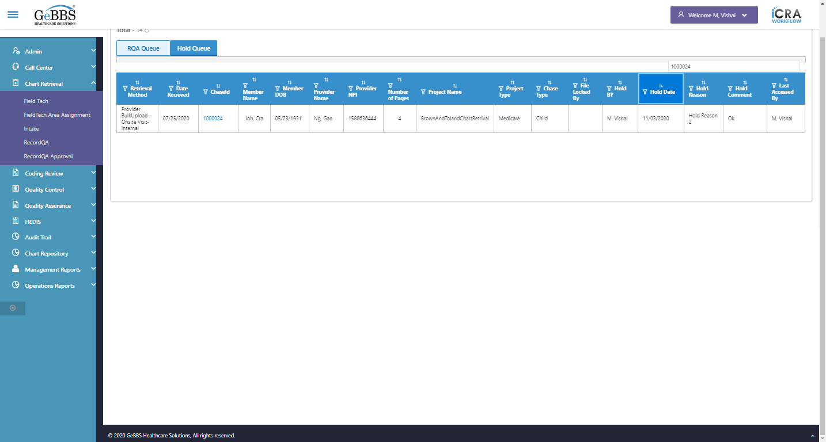  
Sort is clicked  
14 th dsc-sorting is displayed  
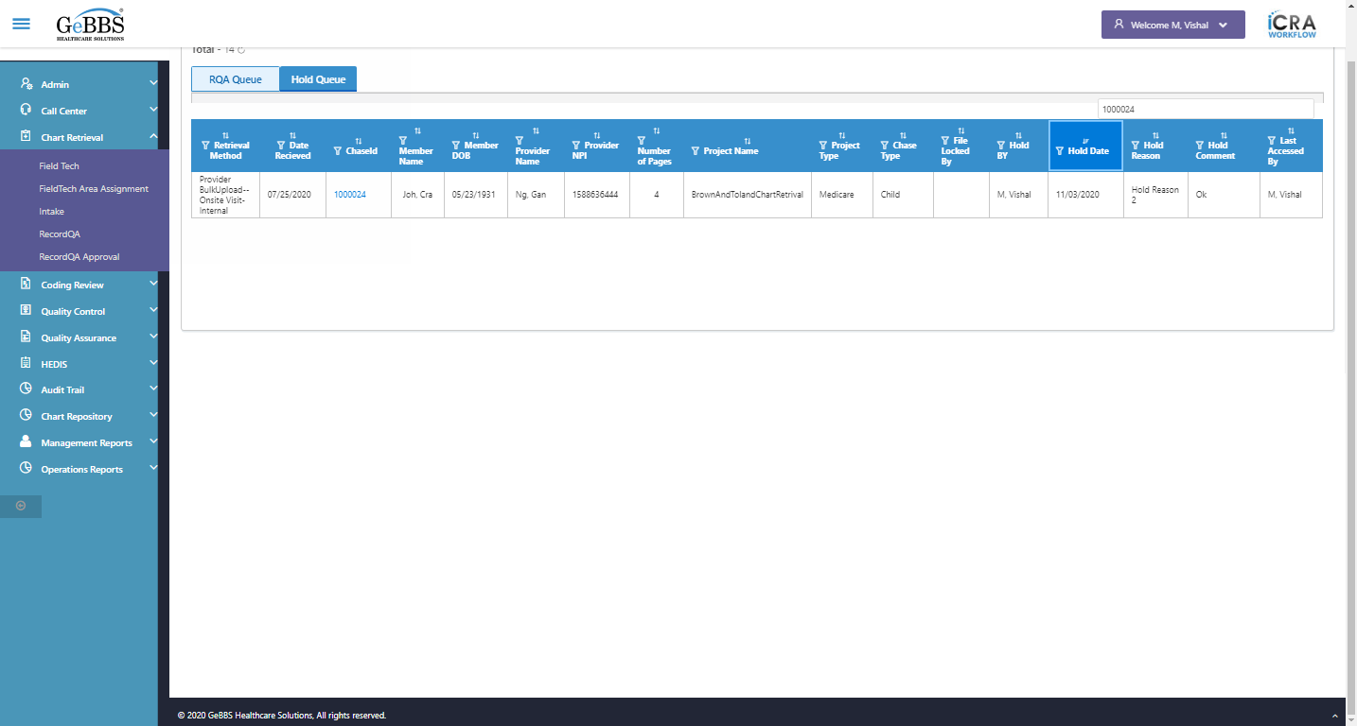  
 Hold Reason is displayed  
  
text is correct  
  
15 th filter is displayed  
  
Scrolled successfully  
15 th sorting is displayed  
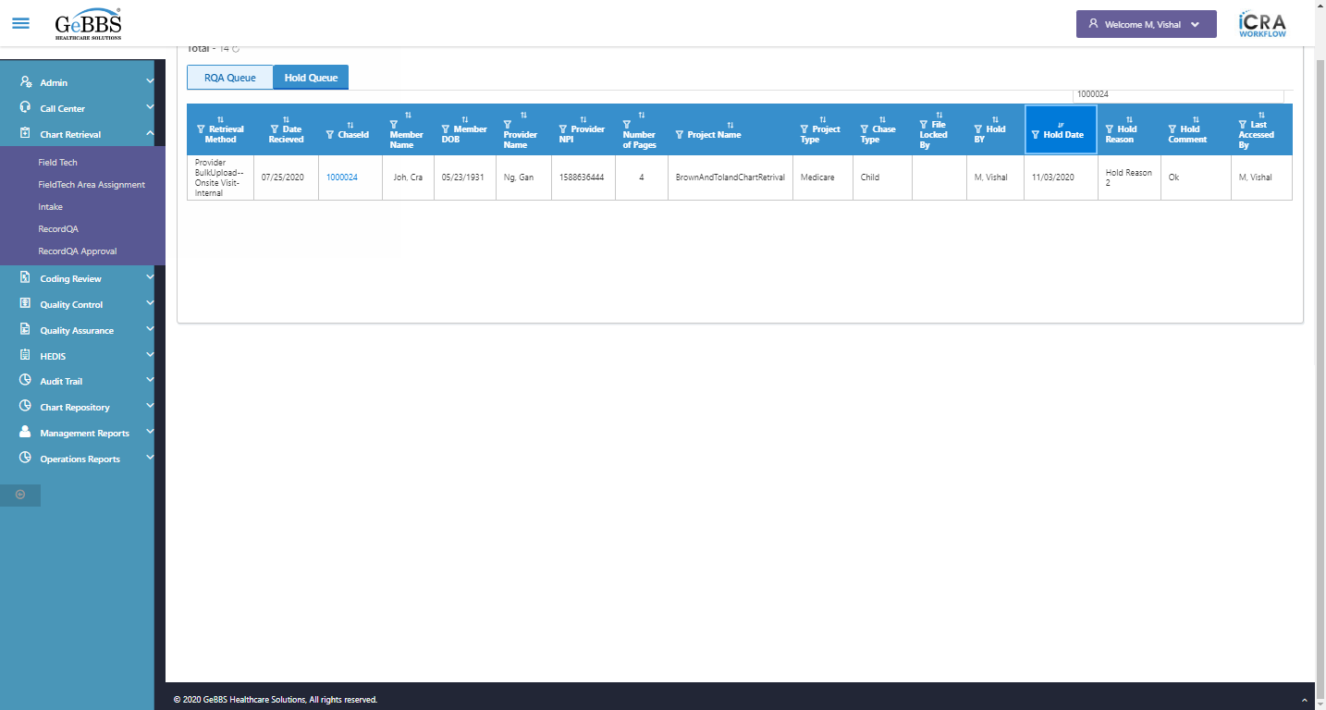  
Sort is clicked  
15 th Asc-sorting is displayed  
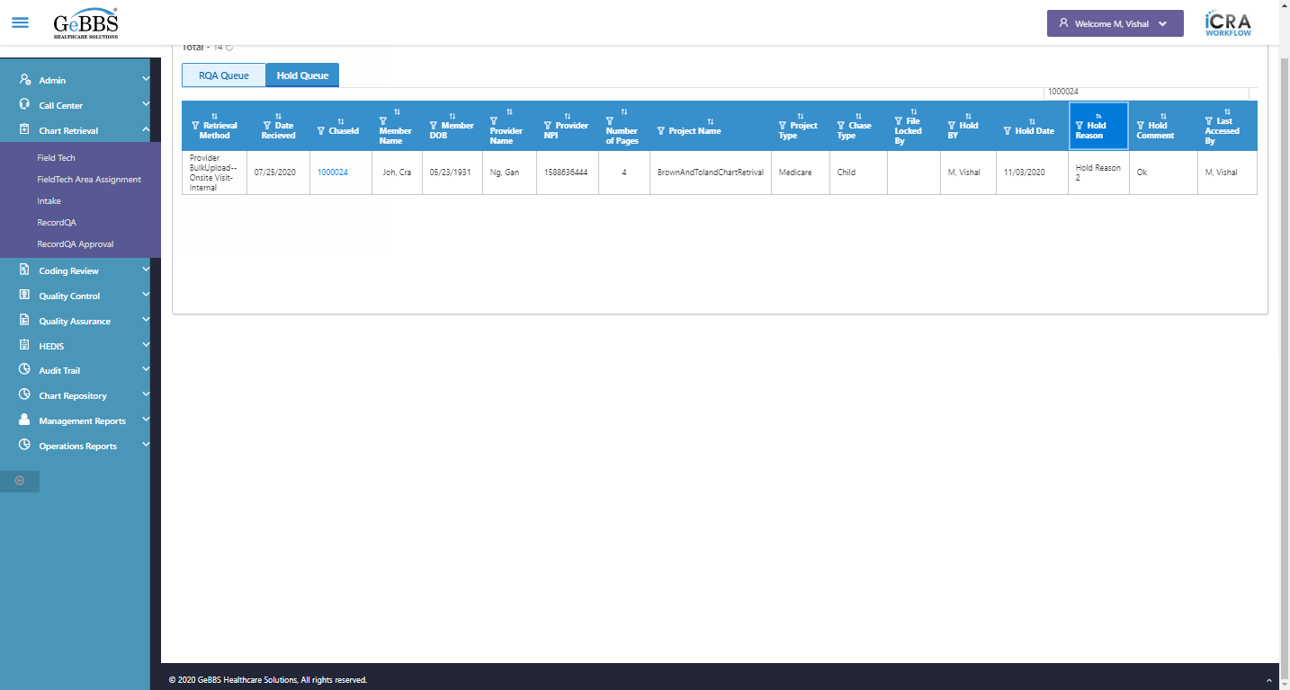  
Sort is clicked  
15 th dsc-sorting is displayed  
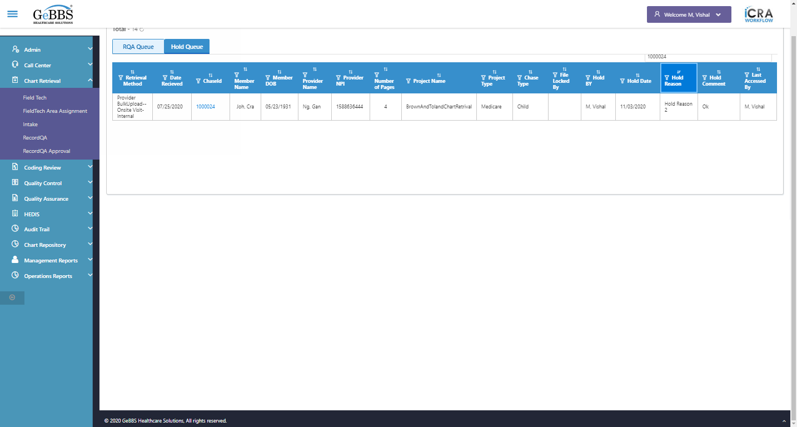  
 Hold Comment is displayed  
  
text is correct  
  
16 th filter is displayed  
  
Scrolled successfully  
16 th sorting is displayed  
  
Sort is clicked  
16 th Asc-sorting is displayed  
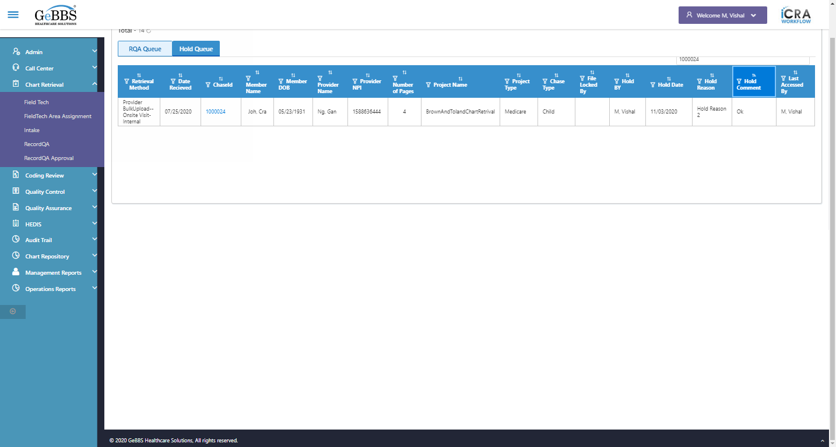  
Sort is clicked  
16 th dsc-sorting is displayed  
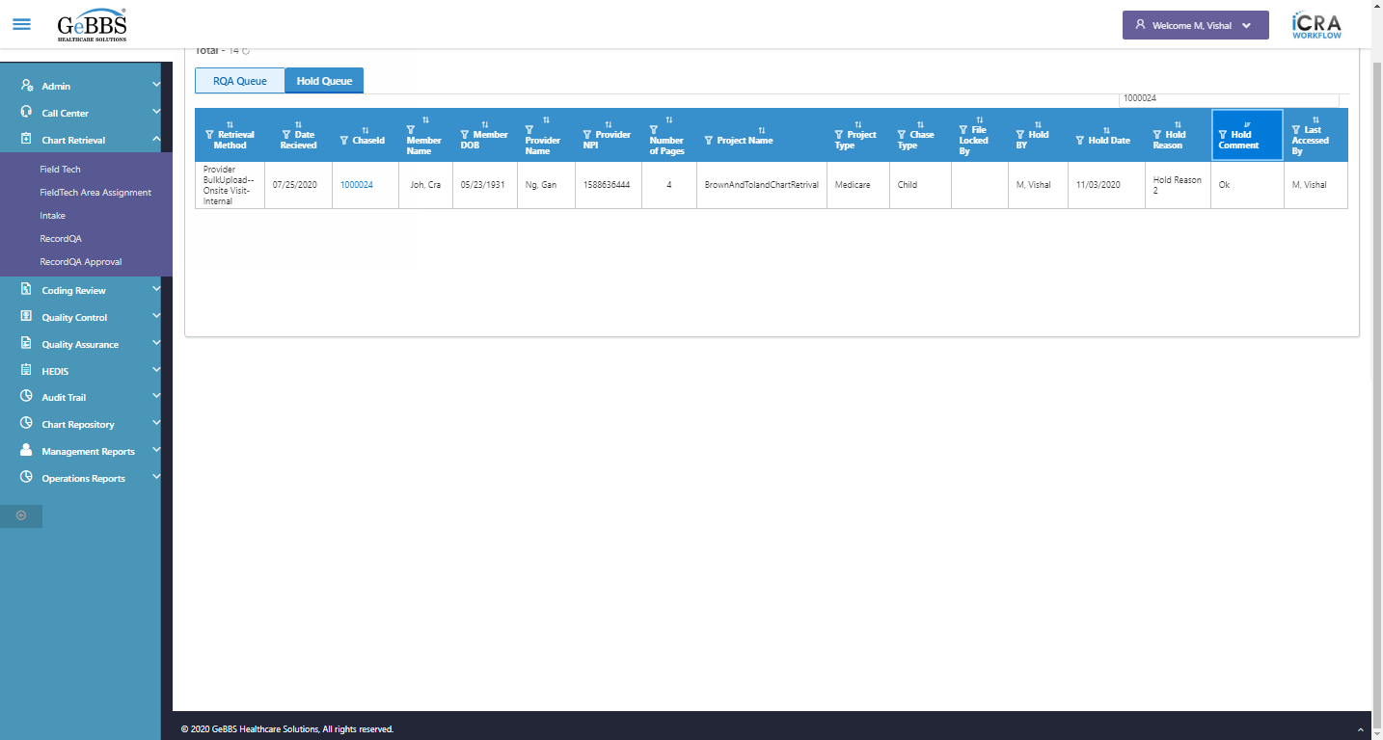  
 Last Accessed By is displayed  
  
text is correct  
  
17 th filter is displayed  
  
Scrolled successfully  
17 th sorting is displayed  
  
Sort is clicked  
17 th Asc-sorting is displayed  
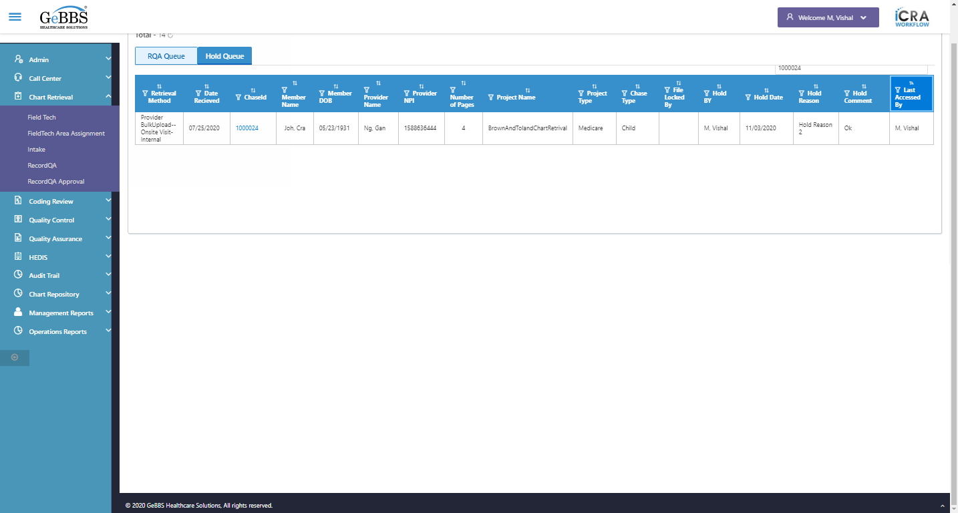  
Sort is clicked  
17 th dsc-sorting is displayed  
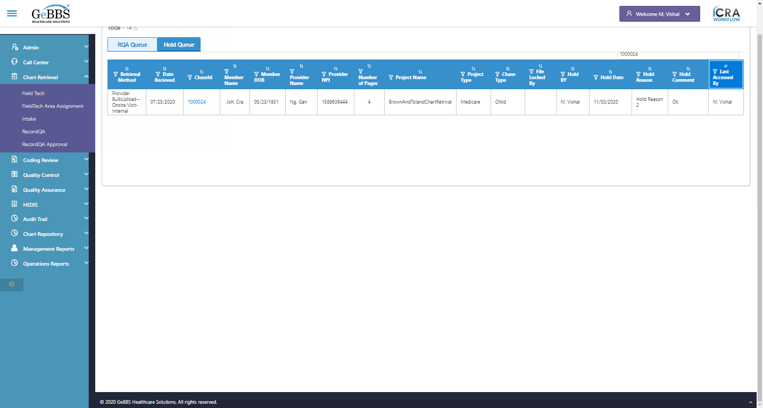  
Chase,Hold Comment and Hold Reasonr is correct in Hold Bucket  
  
*****HoldTest is Ended ***** **03/11/2020 15:36:24**